12th August 2019

**ADAC TCR Germany celebration for Michelle Halder**

The Dutch circuit of Zandvoort hosted the fourth round of the ADAC TCR Germany series at the weekend.

The series boasts the Japanese premium tyre manufacturer YOKOHAMA as exclusive tyre supplier and in this round – the fourth from seven race weekends, 15 cars took part.

This time, the windy weather that battered parts of Holland and Belgium was not the only protagonist. The Dutch races saw the young 18-year-old German driver Max Hesse (Hyundai i30 N) take the first victory of the weekend and his maiden win in this championship. Max has been competing since 2017 when he stepped up to racing from karting. The performance of the teenager was superb in race 1 and managed to beat Mike Halder (Honda Civic) by two seconds and Harald Proczyk (Hyundai i30 N), 2018 champion, by 3.6 seconds.

In the second race, Michelle Halder (Honda Civic), who is also Mike's sister, claimed a superb start to finish win and the first victory of a female driver in this championship. Michelle beat the Finn Antti Buri (Audi RS 3 LMS) by 1.1 seconds and her brother by 1.6 seconds.

After the Dutch event, the Finn Antti Buri leads the championship with 270 points, 12 more than Harald Proczyk. The next round of the TCR Germany will be held at the Nürburgring next weekend.

“Yokohama has motorsport in its DNA and supports numerous motorsport championships and races around the world. With our know-how and tyre technology, we at Yokohama are always looking for ways to improve our products, so that we can develop high-performance tyres to produce more champions on the track and to manufacture more environmentally friendly and safer tyres on the road.” Added a YOKOHAMA spokesman.

Current Driver standings

1. Antti Buri 270pts

2. Harald Proczyk 258

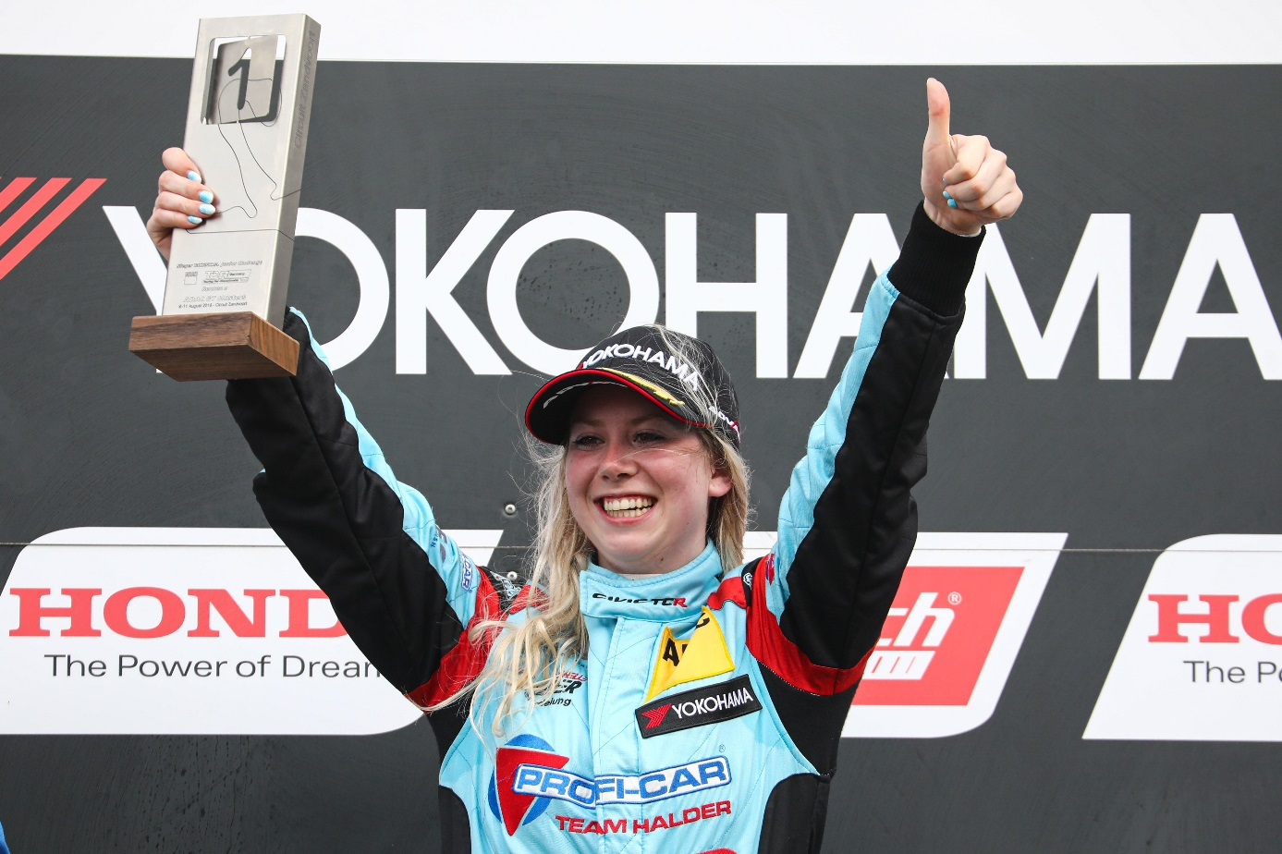

Michelle Halder wins Zaandvort race 2